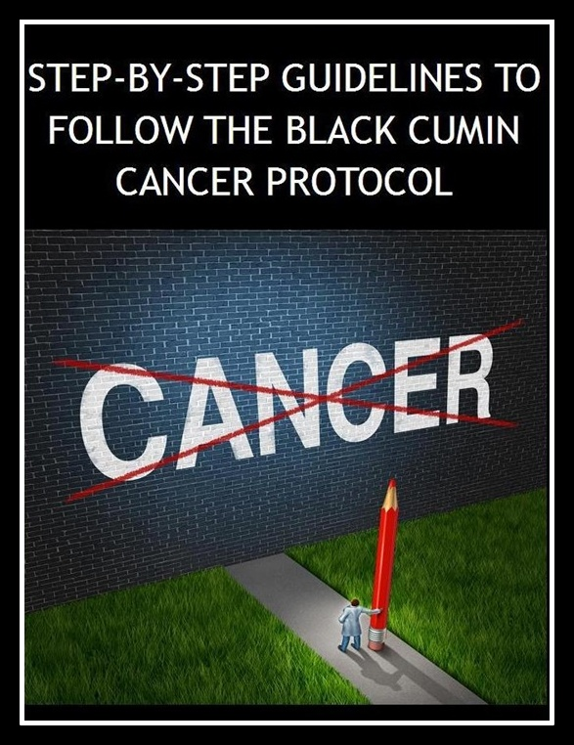

Step-by-Step Guide to Healing Cancer with Nigella Sativa

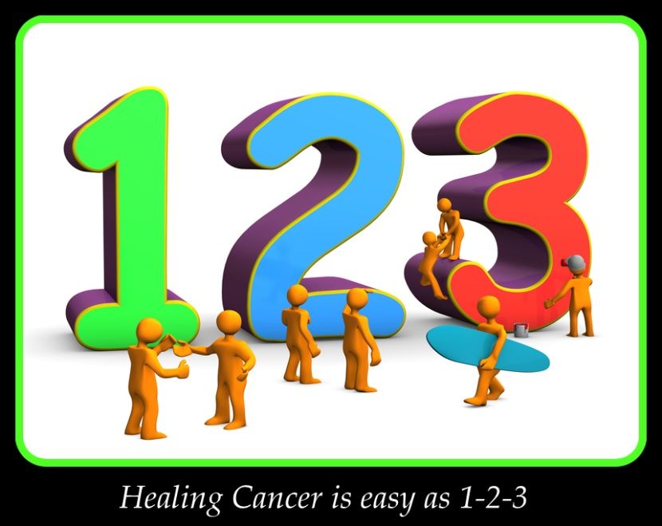

A detailed guide to follow the Black
Cumin (Nigella Sativa) Cancer Protocol.

Learn how to implement the entire protocol from taking
the oils properly to supplementing must have nutrients and following her new protocol. Healing your cancer is possible when you have full knowledge of the entire program.

This guide is a must read for anyone with cancer or who wants to prevent cancer for theirself and their loved ones.

FOLLOW ME ON YOUTUBE TO SEE ALL MY VIDEOS ON CANCER

Copyright © 2021 -2028 BSE Imports/Exports
All rights reserved. ISBN-13: 978-1533602664

Copyright Notice The content of this book is copyright protected. All rights reserved. No part of this book may be reproduced or transmitted in any form, or by any means, without prior written permission of the author, except in the case of brief quotations embodied in critical reviews and certain non-commercial uses permitted by copyright law. For permission requests, contact the author.

CONTACT INFO:
Email: https://www.nigellasativacenter.com Website

Disclaimer:
Note: The author of this eBook is not a doctor or a medical practicioner and I cannot legally give out medical advice or to make medical claims. Moreover, even doctors cannot claim to tell you what will cure you according to the FDA except by using an FDA approved drug. Even though black seed has been used for thousands of years along with the other remedies I will share, I cannot legally say they are cures, but I can write about works for me and my clients and then it is up to you to decide.

“Health is a state of complete harmony of the body, mind and spirit. When one is free from physical disabilities and mental distractions, the gates of the soul open.” ~B.K.S. Iyengar

“In order to change we must be sick and tired of being sick and tired.” ~Author Unknown

“Mainstream medicine would be way different if they focused on prevention even half as much as they focused on intervention…” ~Anonymous

You have suffered for years and years and I could have cured you in 30 days.

Foreword

I want to congratulate you on taking the first step towards treating your cancer with Nigella Sativa, also known as black cumin, kalonji and black seeds. By the year 2020 you will see cancer double in statistics from the year 2000 and by the year 2030 cancer statistics will triple.
Research has shown that people who chose chemo as their cancer treatment will have a 2.1% chance of survival after 5 years. So you will see more and more switching to alternative healing modalities and I am pleased that you have chosen to begin a new life starting today with Nigella sativa.
There have been more than 900 peer research studies showing the efficacy of Nigella sativa and many of those studies have centered on the ability of Nigella sativa to treat cancer successfully.
Nigella sativa has been shown to annihilate cancer tumors in pancreatic, breast, colon, prostate and liver. Other testimonies, such as mine has proven Nigella sativa successful in stomach, bone and brain cancers.
The more researchers search for new evidence the more you will see doors open up for all cancers.
Narrated Abu Huraira: I heard Allah’s beloved Prophet (PBUH) saying ”There is healing in Black Seed for all diseases except death.”

TABLE OF CONTENTS
Chapter 1 –The Health You Deserve
Chapter 2 - What is Faith Healing
Chapter 3 - Why are Doctors Treated Like Gods
►Cause of Illness
►Tumor Reseeding
Which is Better – Seeds or Oil
Are Capsules as Good as Oil
Chapter 4 - The Basic and Advanced Protocol
►The Honeycomb Protocol
Saffron Infused Black Seed Oil
Chapter 5 - The Cancer Diet
►Top Cancer Fighting Foods
Stage 3 and 4 Protocol
Chapter 6 - How to Begin the Protocol
Chapter 7 - Optional Cleansing Protocols
Chapter 8 - Conclusion
Consultation with Sam
How to Locate Sam

***********************************

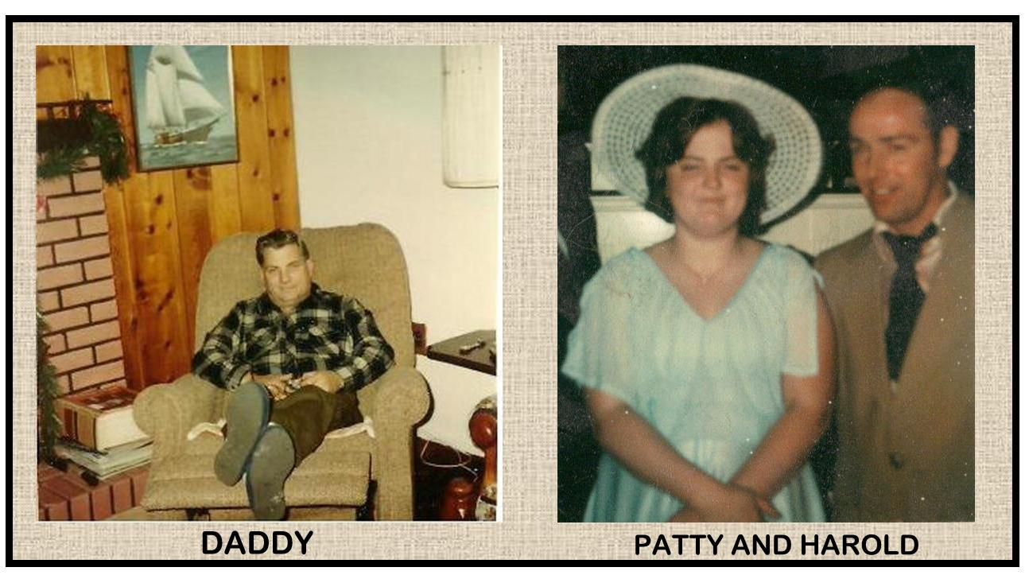
Dedication
I want to dedicate this book to my father, Jack Ellison and my sister Patty. They both had brain cancers and died horrible deaths. They depended on conventional doctors and treatments.
I remember dad's doctor told me "You just have to accept that your father is going to die." He was heartless and cruel. He would leave dad waiting in the waiting room for hours when dad was so sick he could not sit up. He gave dad chemo, knowing it was not going to heal. He wanted to get the pharmaceutical rebate and he could care less about my father.
Dad had so much faith and he did everything religiously to be well again and traveled around the states visiting his family to make amends for anything he did wrong.
Daddy loved to go fishing, but could not go anymore due to his health and his friends shunned him. He would cry all the time and dad never cried. We found out later it was the medicine that made dad so emotional.
In the end after all the chemo was done, they discovered two lumps on dad's lungs. If he had cancer on one lung, they could have operated but two was too much. So we brought dad home and in 30 days he was no more.
My sister Patty died in 1 and half years due to the fact she had inoperable cancer. I was so happy she was out of pain and suffering.
I swore I would never ever go through what they did and never did. I cured my own cancer with black seed and luffe. I never entered a chemo drip or relied on a corrupt doctor to save my life. The one that saves lives is God. God alone has the power to help.

Acknowledgements
I would not be here today if it were not for the help of many people. Many researchers before me did the work and provided the backing for this protocol. There has been more than 600 peer reviews. The first review I read was by the Kimmel Cancer Research University with their work on pancreatic cancer. They showed that Nigella Sativa had an 80% Cure rate.
That means 8 out of 10 people will live. Compare that to the conventional treatments were 2 out of 10 live. I knew then that a cancer protocol had to be created and shared.
Through careful research by many others I came up with a multi-prong protocol that would help more than 8 out of 10 people be well. If I could find the right synergy of natural herbs, we could help people walk, talk and live productive lives.
While I can't guarantee success, I can tell you from experience and testimonies, the protocol works.

Who Should Buy This Book?
Everyone! At the rates of sickness we see in the West, you are virtually guaranteed to experience one or more chronic, degenerative disorders by the time you are 50. This is not just a cancer book, but a wellness book and this protocol can be used for many diseases.
- Cancer
- Heart Disease
- Diabetes and Pre-diabetes
- Fibromyalgia
- Alzheimer’s, Parkinson’s and Dementia
- AIDS
- Cohn’s, Colitis, Celiac, Diverticulitis
- Autoimmune Disorders – including MS and Rheumatoid Arthritis Many others!

If we fill our hours with regrets of yesterday and with worries of tomorrow, we have no today in which to enjoy our existence. Seize the day, and take control of your health and life. How you are going to live those tomorrows will depend on how you act and choose today.- George Allibone M.D.

Lynn
I met my client through a friend who offered to help her. She was stage IV breast cancer with a previous stroke. She had no memory and could not recognize her friend. I was asked to help.
So we did an interview and got the basics down and I made my recommendations. Lynn was happy as she had an organic garden in her back yard.
We worked on the protocol she needed and her friend paid for everything and even purchased two months supplies so she did not run short.
I gave her full instructions on how to do the Budwig Protocol too and she was able to purchase the supplies in a herbal store near her.
I asked for a few days to get the "honeycomb protocol" ready. Lynn's friend was so cooperative and anxious to get started. After the boxes arrived, Lynn started right away on the diet and lifestyle changes.
The results were remarkable. Here is what her friend told me.
Hello:
Lynn is doing famously! Her blood sugar dropped to 112; her large breast tumor is now falling in on itself; the smaller tumor is less than half size; her blood pressure is normal now; and she has lost over 20 pounds! Goes Kayaking, works in her garden and has joined a writers’ club. I’d say she was well on her way.
I want to order the next 30 day package. Again, we owe you a big hug for your protocol!
Hi Again:
An interesting update on Lynn’s condition. We spoke before about the fact that Lynn had a debilitating stroke – couldn’t walk or talk for almost a year. As mentioned, she is past all of that but had a remaining disability when it comes to reading and following instructions, some problems with alphabetical items, and much trouble with finance issues. She told me Friday that her mind is clearing! Her memory has improved to the point that she is now able to remember the names of the 16 people in her writing club after only two meetings! This is remarkable for her and she is very excited. I think we can plan on nothing but further improvements beyond the cancer!
Lynn, her son, and I are very, very grateful to you and to your program!

Note: We use to recommend self help and self implying of the protocols. We no longer do that. Guidance is so important. We suggest you sign up for coaching, so we can help you live longer. If you have cancer or any disease, you may not have time to reconsider later. Be smart and go the extra mile.

Introduction
Black seeds, also known as Nigella sativa, black cumin, kalonji seeds and haba al-barakah (Arabic phrase) have been used by people for thousands of years. Some associate black caraway with black seeds and they come from two different plants. Kalonji seeds are found in India and haba al-barakah is an Arabic word and used in the Middle East mainly. Black seeds are commonly used in the kitchen also in many recipes.
Nigella sativa (black seeds), an annual flowering plant that grows to 20-30cm tall, is native to Asia and the Middle East. The flowers of this plant are very delicate and pale colored and white. The seeds are used in Middle Eastern cooking, such as in their local breads. The seeds are also used by thousands for their natural healing abilities. ​
Black Seed is considered to be the greatest healing herb of our time and it has been much neglected. It is being used to strengthen the immune system, fight and irradiate Prostate Cancer and other tumors, purify the blood and increase longevity. Black seed was found in King Tut's tomb, proving the value of this herb to the Kings. ​
Nigella sativa or black seeds is from the prophetic remedies. It was used by both Muslims and non-Muslims for thousands of years. The seeds were used by the ancient Romans in cooking and the Asian herbalist for many remedies, including migraines.
The name Nigella sativa comes from the Latin word, nigellus, meaning black. Nigella sativa is small black seeds, with a slightly rough texture and it has an oily interior.
Narrated Abu Hurairah: I heard Allah's Apostle saying "Use this Black seed; it has a cure for every disease except death." (Hadith of the Prophet from Sahih Bukhari)
Prophecy of the Black Seeds ​
Prophet Mohammad was quoted as saying, "There is healing in Black Seed for all diseases except death." It is also believed that honey was part of the blessed seed treatment. It was part of the tradition to put some honey and ground whole black seeds in the palm of your right hand and lick it up with your tongue. In the days of Prophet Mohammad there was no black seed oil. ​
Black Seed Oil Treasured by King Tut
Black seed oil was found in the tomb of King Tut proving that the important kings found value in this seed. It was a sign also that of all the gold and diamonds he possessed, black seed oil was part of what he chose to take to the next life. The black seeds were found in his tomb also.​
​
History of Nigella Sativa ​
To understand the history of Nigella sativa you need to know more of what has happened in the past. Black seeds can be traced back to over 3000 years. ​
Black seed has been used extensively as an herbal remedy and as a food condiment for thousands of years. It has an abundance of names and is most commonly referred to as black seed or black cumin seed in Western countries.
Mentioned in the Bible​
Nigella sativa was referenced in the book of Isaiah of the Old Testament. It was called "ketzah." Ketzah was used for cooking and for a spice. Ketzah is a Hebrew word for black cumin or Nigella sativa. Isaiah compares the reaping of black cumin with wheat. “For the black cumin is not threshed with a threshing sledge, nor is a cart wheel rolled over the cumin, but the black cumin is beaten out with a stick, and the cumin with a rod.”(Isaiah 28:25, 27 NKJV). ​
Recommended by the Prophet Muhammad (Peace be Upon Him) ​
Prophet Mohammad (peace be upon him) stated, "Hold on to the use of the black seed for indeed it has a remedy for every disease except death." "Hold on," indicates that one should take the remedy daily and take it often and regularly. ​
Assyrian Herbal Book​
An Assyrian herbal book explains black cumin seed as a remedy internally for stomach problems and externally for ears, eyes, mouth and many skin problems, such as itching, rashes and sores. Nigella sativa was also used for herpes. ​
King Tut's Tomb​​
The black cumin oil and seeds were found in King Tut's tomb proving how valuable it was. The honey and seeds were also found in the tomb indicating that this was a prescribed way he took this miraculous medicine. Cleopatra was also known to use the oil for her beauty and her health. Queen Nefertiti who was admired for her beauty, also used the black seed oil. Doctors and the Pharaoh used the black seed oil and the seeds to treat people with such ailments as: colds, headaches, digestive problems and allergies. ​
Used by all Naturopath Masters​
The blessed seed Nigella sativa was also used by Hippocrates in the 5th century B.C. He claimed that Nigella sativa was a valuable remedy in hepatic and digestive disorders. Pliny, the elder, used the seeds in the first century extensively and wrote in his "Naturalis Historia" (Natural History) about Nigella sativa and referred to it as “Git”. ​
Pliny used its remedy for scorpion stings and snake bites, callosities, tumors, abscesses and skin rashes (eczema). Due to its anti-inflammatory qualities, the seeds were used for head injuries. ​
Greek physician Dioscorides used the blessed seeds for a variety of ailments to include: intestinal worms, headaches, toothaches and nasal congestion. The seeds were also used as a diuretic, to increase milk production and to promote menstruation in women.

Appreciated in Ayurveda ​
Black cumin or Nigella sativa was appreciated for its many qualities and bitter, warming stimulant nature. In tradition and typology of the 3 dos has, black cumin reduces veta and kapha and increases pitta. ​
Black cumin was used for a wide variety of complaints, such as anorexia, certain disorders of the nervous system, discharge and venereal disease.
Nigella Sativa Used in Orient ​
Nigella sativa was used in the orient for stomach problems, diarrhea, flatulence, constipation, jaundice, dandruff, hair loss, skin care, congestion, dementia, infections, worms, menstrual problems and bronchial disorders.
In the 16th to 18th century the German Medical Encyclopedias, Hieronymus Boch, "New Kreutterbuch 1539 and Jacobus Theodorus Tabernaemontanus, and "The new Complete Herbal Book," all gave great respect to Nigella sativa. The oil was used traditionally as others did, but now it was being used on dogs, cats and horses.
Back to the top

IF YOU LIKE WHAT YOU READ. THEN PLEASE PURCHASE HERE

