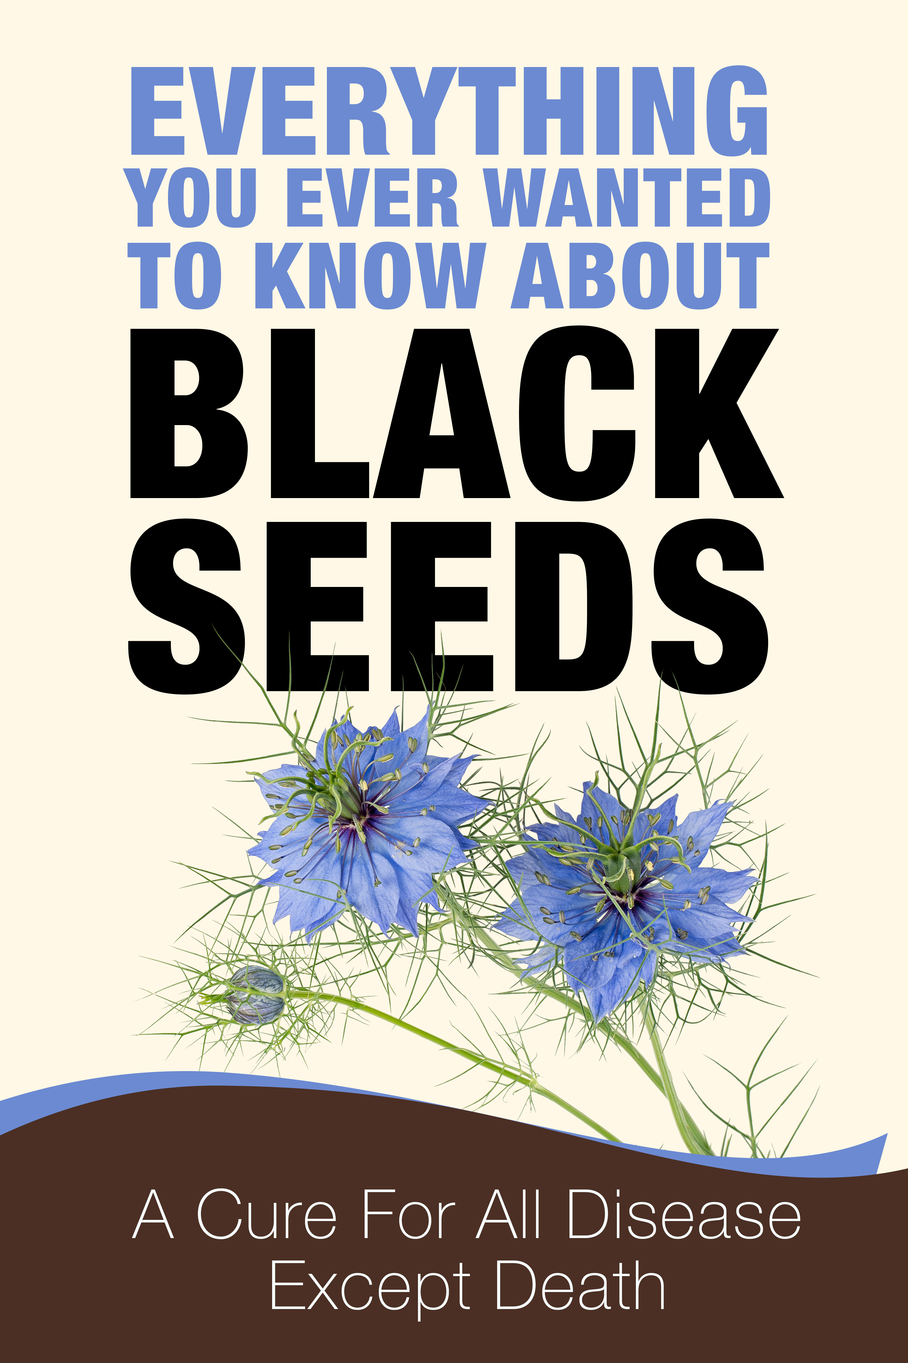
Everything You Would Ever Want to Know About Black Seeds
Also Included is a Chapter on Body Cleansing (Liver, Bowel, Kidney, Parasites)

Copyright 2021 - 2028

**May you enjoy this book more and spread the word about this miraculous seed to others. Please do not copy this book in any form. Instead give your friends the address to order their own copies. This book is copy written for Samantha Davis only and no part may be copied, used or taken without her express permission.

I dedicate this book to those who need help and to those who were helped. I also dedicate this book to my dearly departed husband who is not alive today to see how this little seed took care of his wife much better than he could have ever hoped.

Introduction
Nigella sativa sounds so formal doesn't it; like a technical term in a medical dictionary? It doesn't seem like a simple black seed in a small flower. This small black seed may be your new vitamin pill that just may save your life though. Can Nigella sativa really be the promised miracle drug that comes from Mother Nature?
This may be the very first time you have ever heard of Nigella sativa and its many treatments of disease, including cancer. But I guarantee you that this will not be the last time you ever read about this prophetic medicine called Nigella sativa. This very inexpensive seed just may change your entire life and your future.
My journey to this seed and its miraculous wonders began many years ago. My husband and I migrated to Jordan to take care of his ill father. When we came here there was no work available for my husband, so we became very poor. Poor people cannot afford to go to the doctor and they cannot afford expensive pharmacy drugs.
This lack of money was probably the best thing that ever happened to me. Being poor forced me to live off the land and treat myself as the locals did. The majority of Jordanians are very poor and they are forced to look to the olden days and how the prophets treated their illnesses.
I was sick a lot and when I started checking with the locals as to what they took to get well, one answer always came up and that was "Gizhah," (Arabic for Nigella Sativa). You can buy 1/2 pound of the seeds here for around 50 cents. So the price was right and easy to use. The more I studied, the more I found that this little black seed was the answer I was searching for.
I loved the taste of honey with the black seeds (Nigella Sativa) and in fact it was more like chocolate candy and taking my daily dose was enjoyable. I then started praying over the honey and black seed mixture and saw even more power in the seed. I was hooked on the wonderfulness of this cure.
My body started improving and so was my state of being. My only thought was to be well and help others, not for glory or fame. This was the start of a journey to wellness and a journey to financial freedom. My desire to be illness free would end with the ability to be financially free.
Black Seed - A Miracle From God
Black seed is also known as Nigella sativa, black cumin, kalonji, haba al barakah and gizhah. It has been used for over 2000 years as a relief for all disease and recently it has been studied extensively for cancer, skin disease and inflammation disorders.
Originally black seeds were used for migraines, allergies and acne disorders, but as scientist begin to realize its potential for curing cancer, the research began.
Pancreatic Cancer Research
In 2008 Jefferson Kimmel Cancer Center studied the effect of Nigella sativa on pancreatic cancer tumor cells and discovered that they were able to kill 62% of the cells. Future research by Jefferson showed that with the use of
Nigella sativa, they were able to annihilate or cause cell death on 82% of tumor cells. In addition to the positive results on pancreatic cancer, they found more results worth noting. According to Hwyda Arafat, M.D., Ph.D., associate professor of Surgery at Jefferson Medical Collegeof Thomas Jefferson University, "Nigella sativa helps treat a broad array of diseases, including some immune and inflammatory disorders. Previous studies also have shown anticancer activity in prostate and colon cancers, as well as antioxidant and anti-inflammatory effects."
The studies also showed potential positive results with prostate and colon cancers. Breast cancer has also been studied in separate research showing the ability to eradicate the cancer cells and provide chances for excellent health for many women worldwide. These results caused more and more places to research this simple black miraculous seed. The Middle East frequently studies Nigella sativa and recently they showed positive results for skin disease and gastric ulcers. In both studies, again Nigella sativa was found to be successful.
According to the researchers at Pakistan Journal of Biological Sciences, "The results of this study revealed that fixed oil of Nigella sativa seeds might has potent bactericidal, anti-inflammatory, immune stimulating and/or antioxidant agents that improve healing of staphylococcal-infected skin in BALB/c mice, by inhibiting pathogenic growth and expansion, reducing inflammation and prevent tissue impairment. These effects provide scientific basis for the use of Nigella sativa in traditional medicine to treat skin infections and inflammations."
In November of this year, Naheed Amir, Amina Al Dhaheri, Najla Al Jaberi, Fatma Al Marzouqi, Salim MA Bastaki Department of Pharmacology and Therapeutics, Faculty of Medicine and Health Sciences, UAE University, Al Ain, United Arab Emirates, studied the effect of Nigella sativa, onion and garlic on gastric ulcers and the results showed that Nigella sativa was just as potent as pharmaceutical medicines in the treatment of gastric ulcers. It should be noted that the researchers used raw Nigella sativa that was boiled. In closing the researchers stated, "Boiling did not affect the protective effect of Nigella sativa on gastric ulcers," thus proving that heating the seeds does nothing to its composition.
Benefits of Nigella Sativa:
The world is simply astonished of the many benefits of Nigella sativa and the desire to find the best product grows. There are many other benefits of black cumin, such as:
- Anti-hypertensive
- Anti-Tumor
- Anti-bacteria
- Anti-histamine
- Strengthens the immune system
- Anti-inflammatory
- Promotes lactation
- Anti-parasitic
One of the best benefits of black cumin is the ability to increase immunity. If you feel tired and lethargic and want to find a quick fix, then try this very simple recipe. Take 1 teaspoon of black cumin oil and mix it with the juice of one orange. Drink this mixture 1/2 hour before breakfast and you will see your energy level return. I suggest you do this each morning to improve you immune system and find increased health. For something that is one step above this simple recipe, why not try my honey and black cumin elixir.
Ingredients:
- 1/2 kilo of honey
- 2 tablespoons of royal honey (optional)
- 4 teaspoons of black cumin oil
- 2 heaping tablespoons of ground ginger
- 1/3 to 1/2 cup chopped nuts ( my favorites are almonds, walnuts, pistachios)
Directions:
Put the honey in a large bowl. If you do not have royal honey, you can use all regular RAW honey. Add in our black cumin oil and ginger and mix well. Add in the chopped nuts and stir. Pour the honey mixture into a large jar and seal. Eat 1 teaspoon of this honey mixture daily. You can eat this any time of the day.
References:
Mariam A. Abu- Al-Basal , 2011. Influence of Nigella sativa Fixed Oil on Some Blood Parameters and Histopathology of Skin in Staphylococcal-Infected BALB/c Mice.Pakistan Journal of Biological Sciences,14: 1038-1046.
November 11, 2011, "Comparative effect of garlic (Allium sativum), onion (Allium cepa), and black seed (Nigella sativa) on gastric acid secretion and gastric ulcer," United Arab Emirates University

Note: The author of this eBook is not a doctor or a medical practioner. She writes about her experience, documented research and personal knowledge only. If anyone has a serious illness, please check with your family physician before placing your life or the life of your loved ones in jeopardy.

PLEASE READ MY OTHER EBOOKS HERE
CANCER’S WORSE ENEMY
STEP-BY-STEP GUIDELINE TO THE BLACK CUMIN CANCER PROTOCOL
HOW TO CURE CANCER ISLAMICALLY
DR. SEBI CANCER CURE

TABLE OF CONTENTS
Introduction
Chapter I
•What is Nigella Sativa
•Prophecy of the Black Seed
•History of Nigella Sativa
Chapter 2
•Faith Healing and Spirituality Healing
•Healing Yourself
•Research
Chapter 3
•How Nigella Sativa Works
•Benefits of Nigella Sativa
•How to Heat the Seeds and
•How to Make Honey With Black Seeds
Chapter 4
•Dosage Requirements for the Use of Nigella Sativa
Chapter 5
•Precautions and Warnings About Black Seeds
•Black Seed Oil Myth or Miracle
•Natural News.com Articles on Nigella Sativa
Chapter 6
Places to Purchase Black Seed Oil and Whole Seeds
Chapter 7
•Causes of Illness
•Deworming Natural Remedies
•Liver and Gallbladder Flushes
•Bowel Cleansing
•Kidney Cleansing
Chapter 8
Recipes
*Naan Bread with Black Cumin
*Zalabya with Black Cumin
*Baska Bread with Nigella Sativa
*Lobhia
*Halawa with Gizha (Black Cumin)
*Black Seed Tea
*Cheese Appetizer
*Cucumber Salad with Yogurt and Black Seeds
Exerpts From My black Seed Cuisine Ebook
*Cheese and Black Seed Rollups
Labane Cheese Balls in Olive Oil
Delicious and Healthy Whole Wheat Bread
Zatar
Oatmeal with Flax and Black Seed Oil
Cheese Appetizer
Cucumber Salad with Yogurt and Black Seeds
Resources
Consultation
How to Locate Sam

YOU CAN PURCHASE THE ENTIRE EBOOK HERE

